Jackson Warren

Jeremy Bergen

CSCI 370

9/24/21

Week 4 Lab

Section 1:

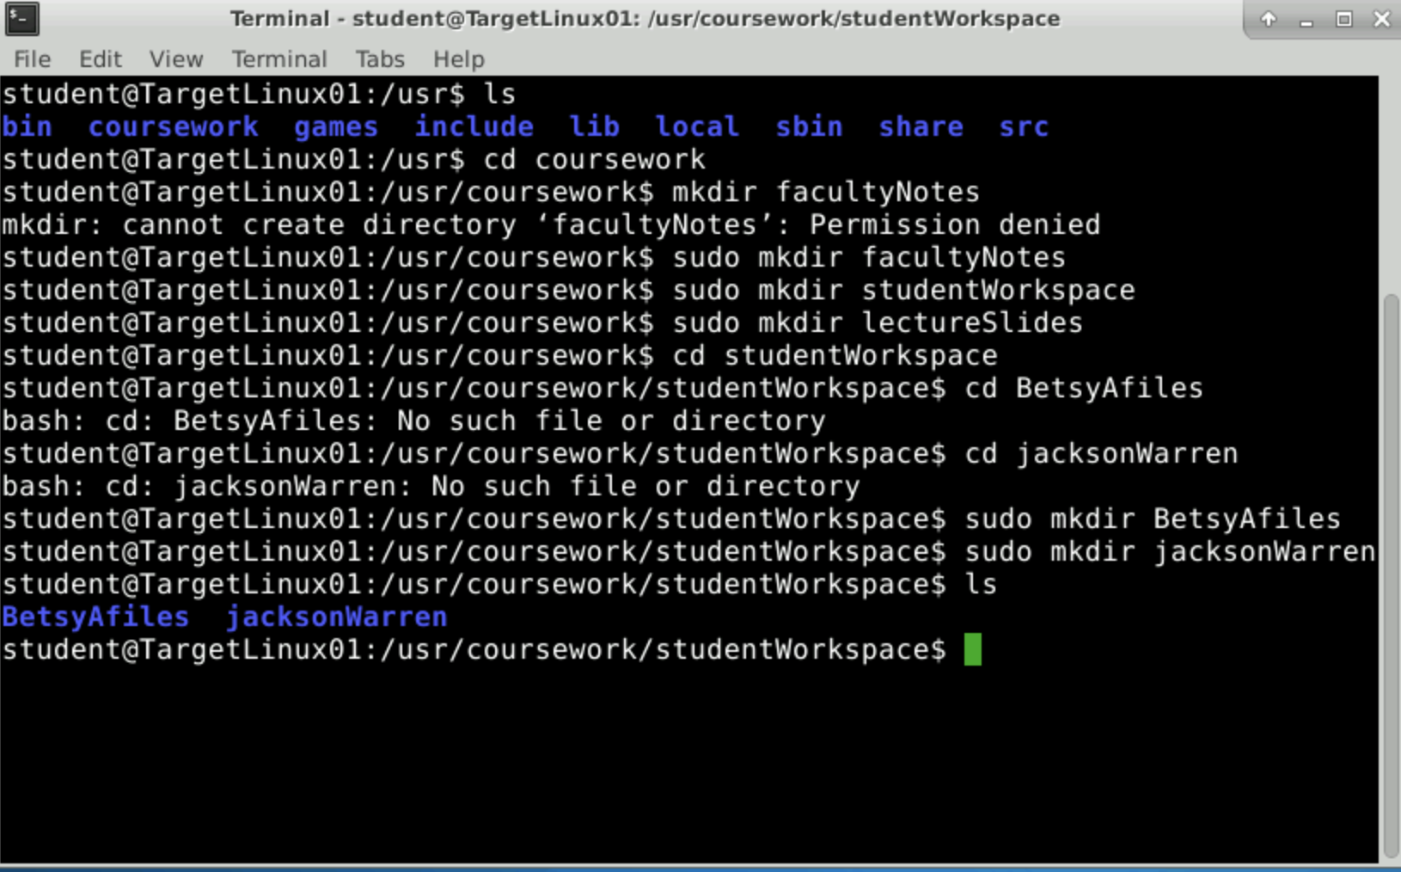

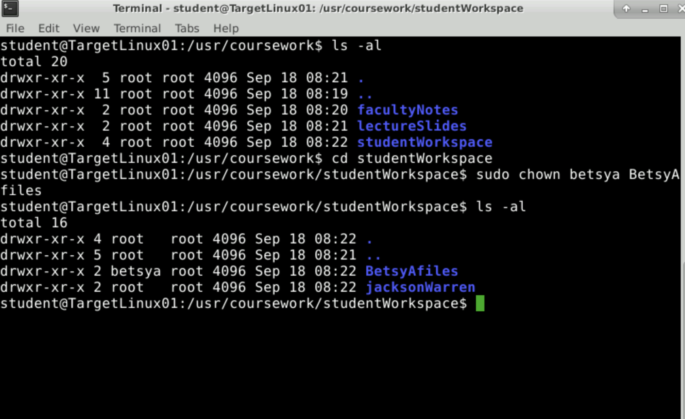

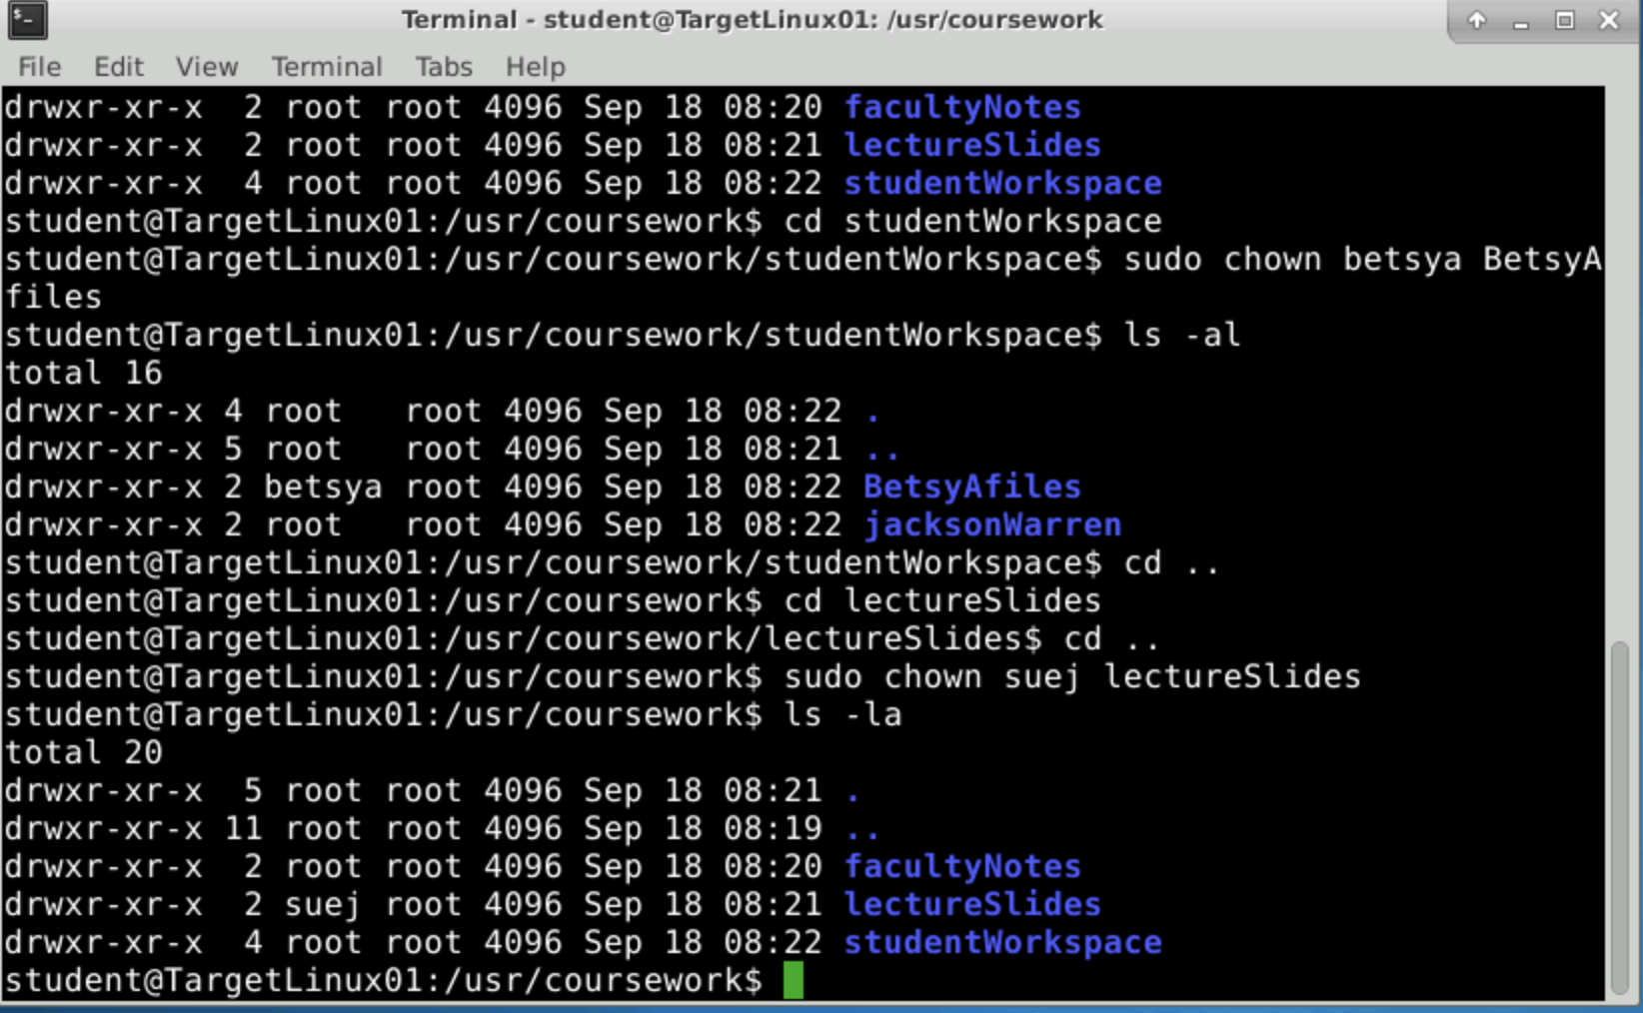

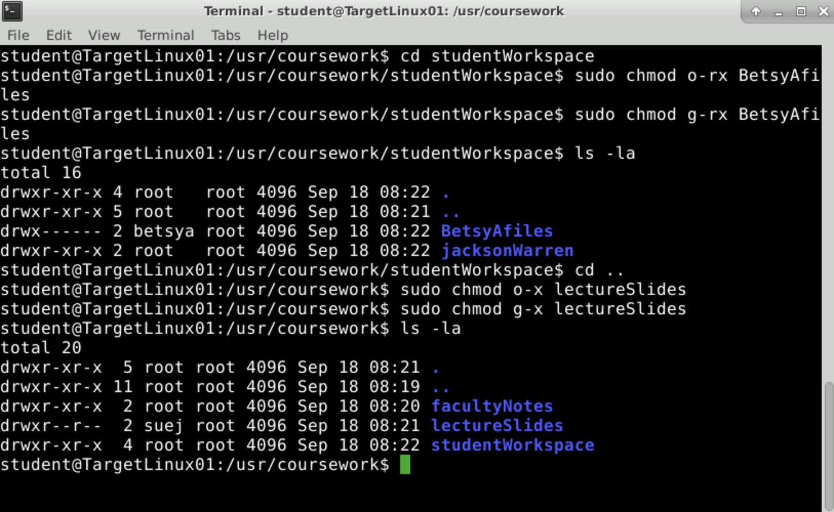

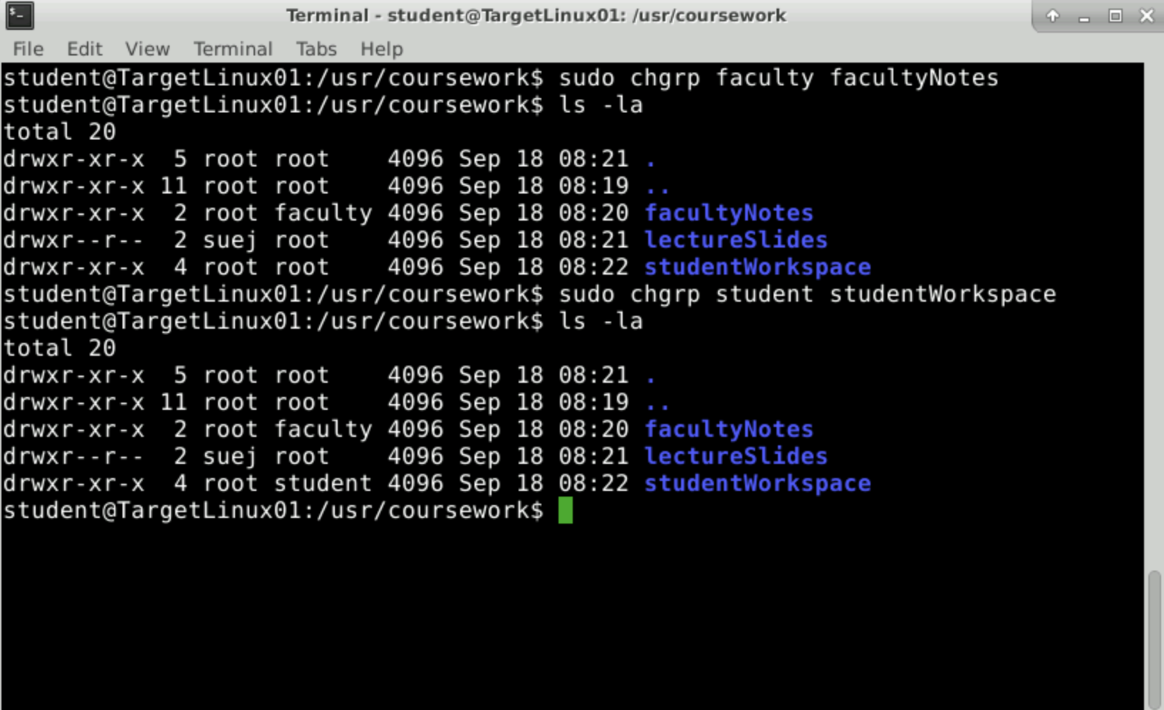

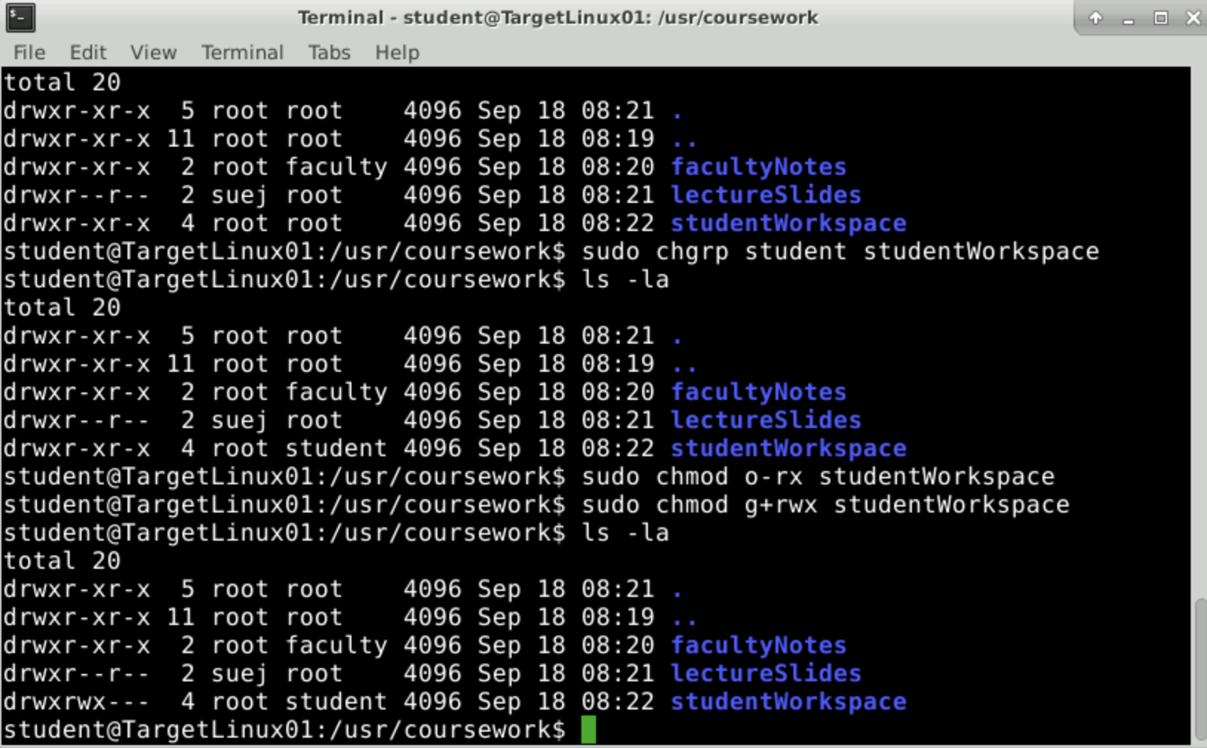

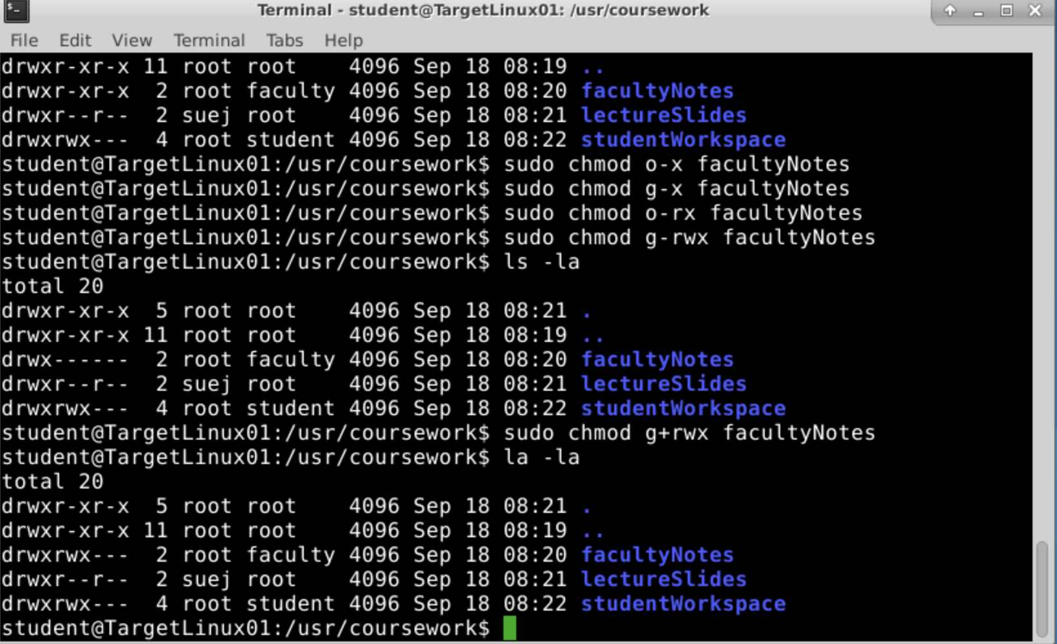

Section 2:

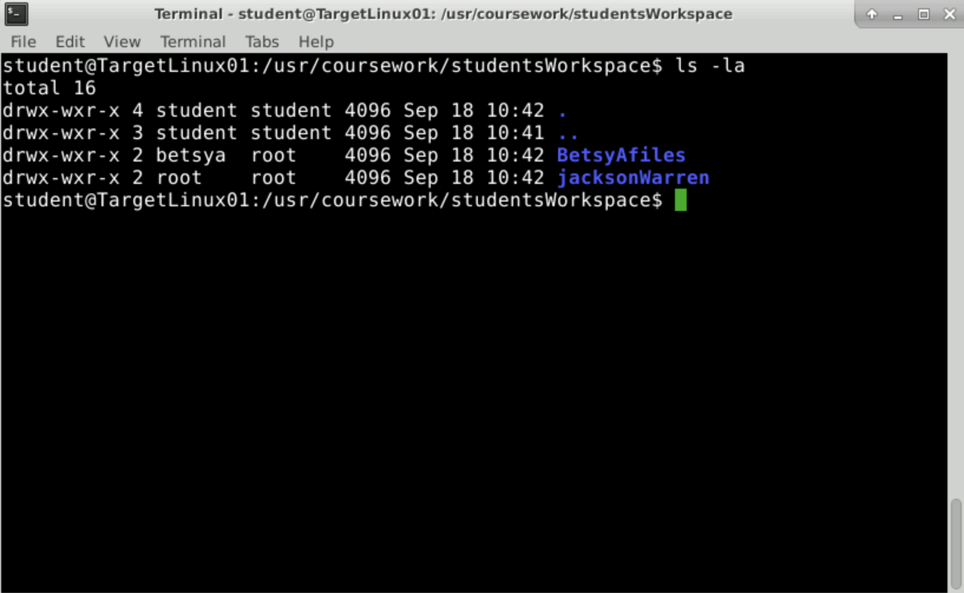

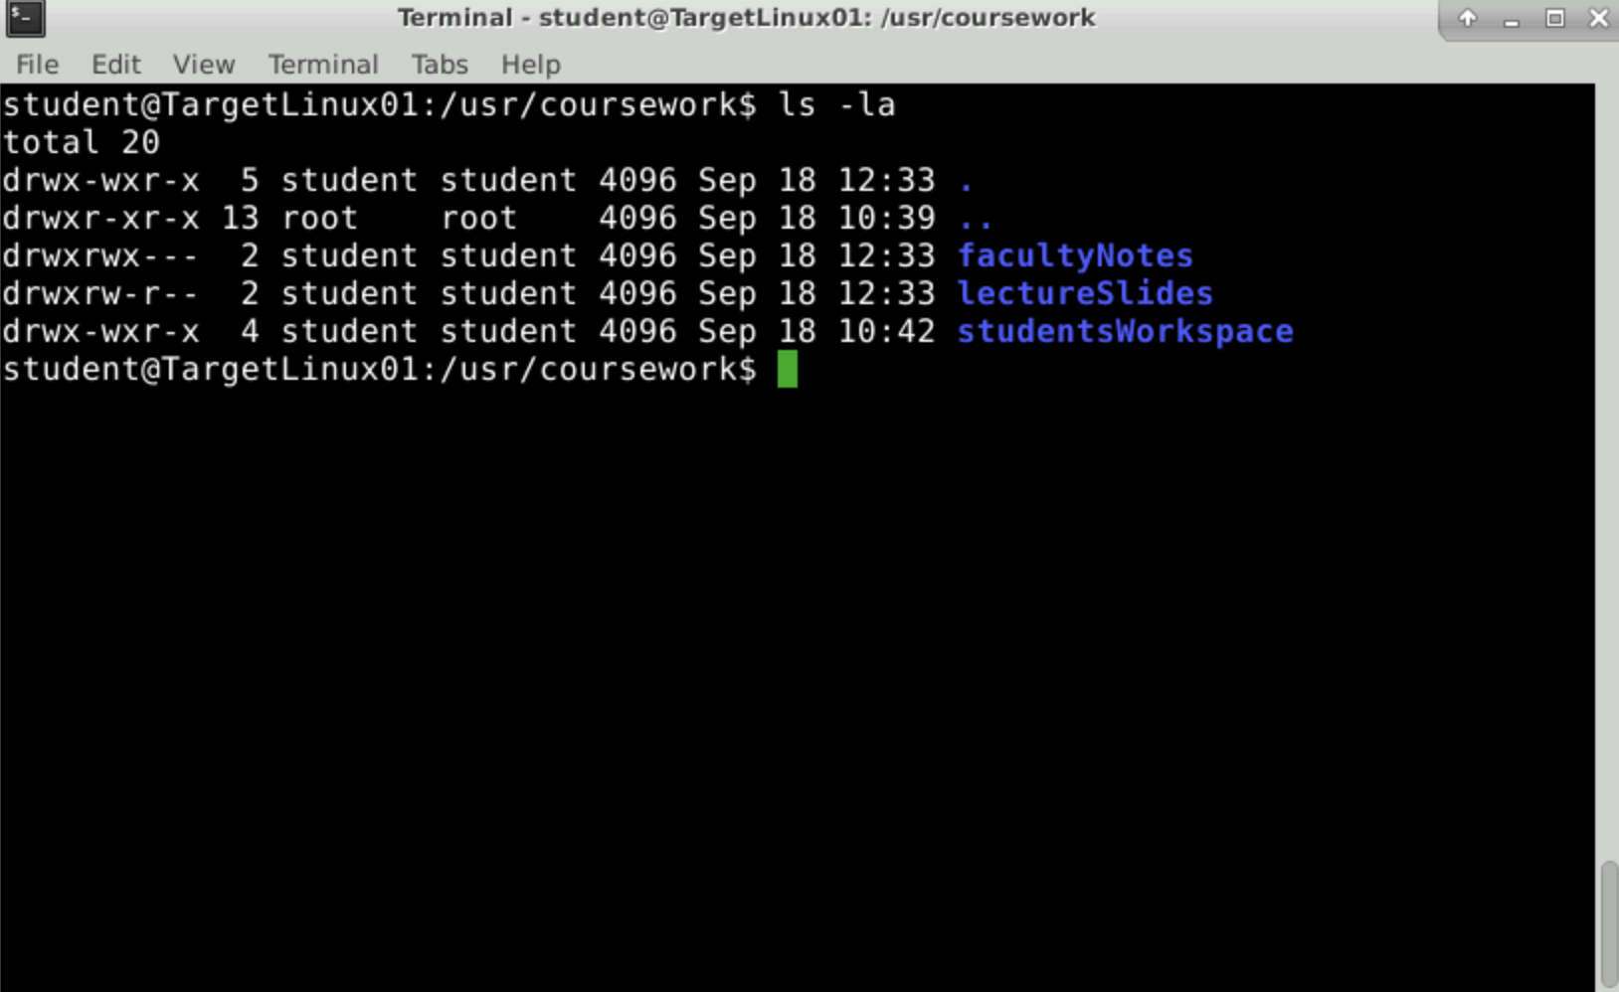

Section 3:

Part 1:

BASH – Bash is a shell that adds features to the current shell, such as command line editing.

AWK – Allows users to write statements in documents and run them as programs. Essentially, it is a pattern scanner.

YAD – YAD helps with GTK+ dialogs and returning users inputs.

Part 2:

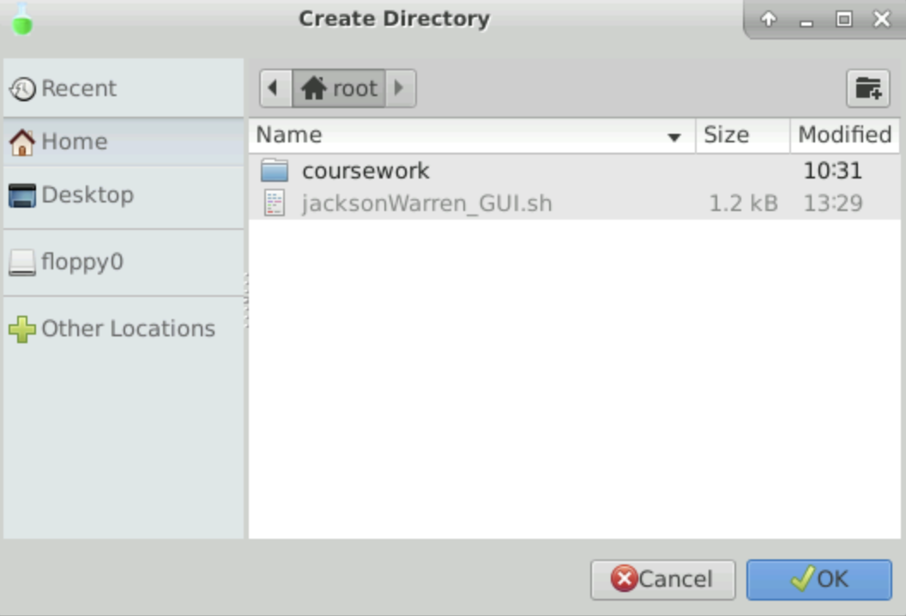

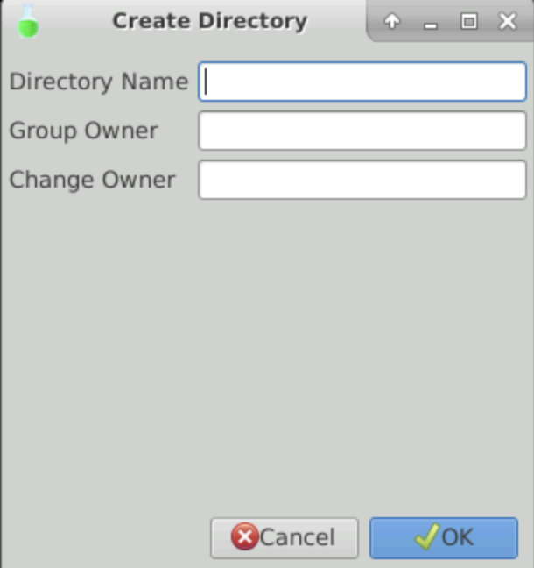

I couldn’t find a selection button option for YAD anywhere. I tried using the --file and --list options for YAD, and go this. I feel like the file selection might be a close idea of what we’re looking for though.

Part 3: 